
PeiZen, Inc.
1227 Flynn Road, Suite 302
Camarillo, CA 93012-6212
Phone: (805) 484-2454, FAX: (805) 383-5909
e-mail: hlee@flatmonitors.com
Website: www.flatmonitors.com

Q-1920-RK

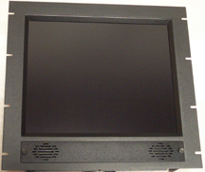

This is a 10U or 17.5” high 19” TFT LCD rackmounted monitor.

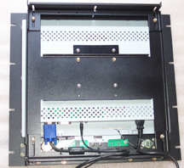  Rear view showing the Cornea Technology’s CT1904 assembled onto to the Q-1920-RK rackmount kit. | This rackmount kit is designed specifically for those 19” TFT LCD monitors that have a larger frame than the thin frame monitors such as the Samsung 910T-Black or the Viewsonic VP191b.  For examples,  HP L1902,  http://www.flatmonitors.com/hp-L1902.pdf,  HP f1903,  http://www.flatmonitors.com/hp-f1903.pdf,  and Viewsonic’s VX900, http://www.viewsonic.com/products/lcd_vx900.htm will work well with this rackmount kit.

