HI-IQ Products
PeiZen (pay-zen), Inc.
651 Via Alondra, Suite 702
CAMARILLO, CA 93012-8097
Phone: (805) 484-2454, FAX: (805) 383-5909, e-mail: hlee@flatmonitors.com
Website: www.flatmonitors.com

Q-1910-RK
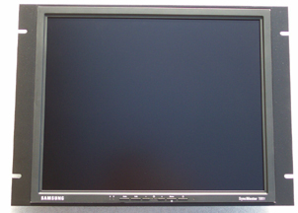

The first 8U or 14” high 19” TFT LCD rackmount monitor on the market.

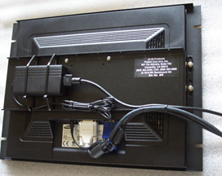  The Samsung 191T-Black monitor has one analog VGA input and one digital DVI-D input. The completed assembly is less than 4” deep, making this rackmount monitor one of the most space efficient. | This rackmount kit was originally designed for the Samsung 191T-Black 19” TFT LCD monitor, which is shown in the photos, but this monitor is now out of production. A monitor that has the same dimensions and still can work with this rackmount kit is the HP L1925. For more information, please click on http://www.flatmonitors.com/hp-L1925.pdf. The Dell 1905FP can also work, but a Q-100mm spacer block is needed. Please click on http://support.dell.com/support/edocs/monitors/r83546/EN/about.htm#Front%20View  This is a very cost effective rackmount display solution. The total cost of this rackmount monitor can be less than $700.00.

