
PeiZen, Inc.
651 Via Alondra, Suite 702
CAMARILLO, CA 93012
Phone: (805) 484-2454, FAX: (805) 383-5909
E-mail: hlee@flatmonitors.com
Websites: www.flatmonitors.com and www.peizen.com

Assembly Instructions

For

Q-1910-RK Rackmount Kit onto Dell 1905FP or 1907FP 19” monitor

Tool required:

- No. 2 Phillips screwdriver
- 3/8” Socket wrench
- 3/8” Crescent wrench
- Tie wrap tool
- Wire cutter, angled tip is recommended

Procedures:

- It is a good idea to power up and test the monitor before assembling it onto the rackmount kit, just in case if there is any problem with it (usually very rare). Otherwise, you may do all the work below and then have to un-do it.

- If the monitor is working fine, then lay the foam packing material that came in the box over a flat surface on a table or workbench. The lay the monitor facing down over the soft foam.

- Push the quick-release button in the back to remove the monitor from its stand. Note: Please store the stand away in the box the monitor came in. In case of warranty service, you will need to re-assemble the stand back onto the monitor.

- Place the Q-100mm 4.50” X 4.50” X 0.50” PVC spacer block over the 100 mm-center VESA mounting holes in the back of the monitor.

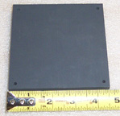 | 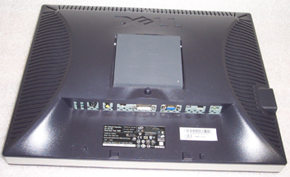

- Mount the U-bracket onto the monitor with four each 4 mm X 30 mm metric screws, No. 8 lock washers, and No. 8 flat washers.

5. Turn the monitor over facing up. Then mount the front plate and position it symmetrically with respect to the monitor. It should fit perfectly into the flanges of the U-bracket.

- Turn the monitor over facing down. Insert No. 10 flat washers and 10-32 locknuts onto the right and left flanges of the U-bracket. Use a 3/8” crescent wrench (or a 3/8” socket wrench that can fit) to secure the front plate.

- Use the 5” tie wraps to secure the cables. Then trim all excess lengths of the tie wraps with a wire cutter.

- The monitor is now assembled. Before mounting it onto a rack, test the rackmount monitor assembly by connecting it to a computer. When done, mount the assembly onto a rack with the four black 10-32 rackmount screws provided.
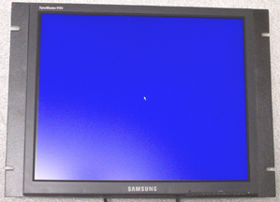

Front View of a similar Samsung monitor.

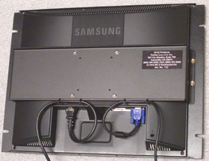
Rear View of a similar Samsung monitor

- Congratulations! You have just completed assembling the best-looking and cost-effective 19” rackmount monitor in the world. If you have any questions or comments, please call Harry Lee, 1-866-484-2454 or e-mail to hlee@flatmonitors.com.

