HI-IQ PRODUCTS
P.O. Box 1198
CAMARILLO, CA 93011-1198
Phone: (805) 484-2454, Toll Free: 866-484-2454
FAX: (805) 383-5909, e-mail: hplee@gte.net
Websites: www.flatmonitors.com and www.peizen.com

Q-1800-RK

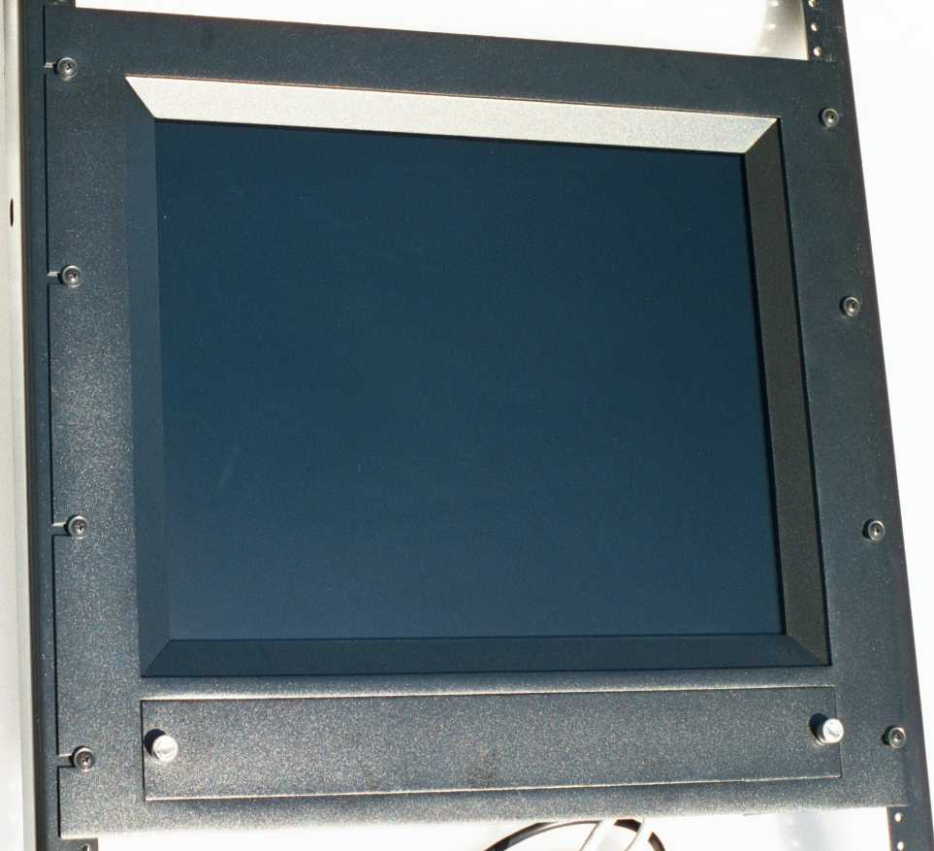
Front view with blank plate closed

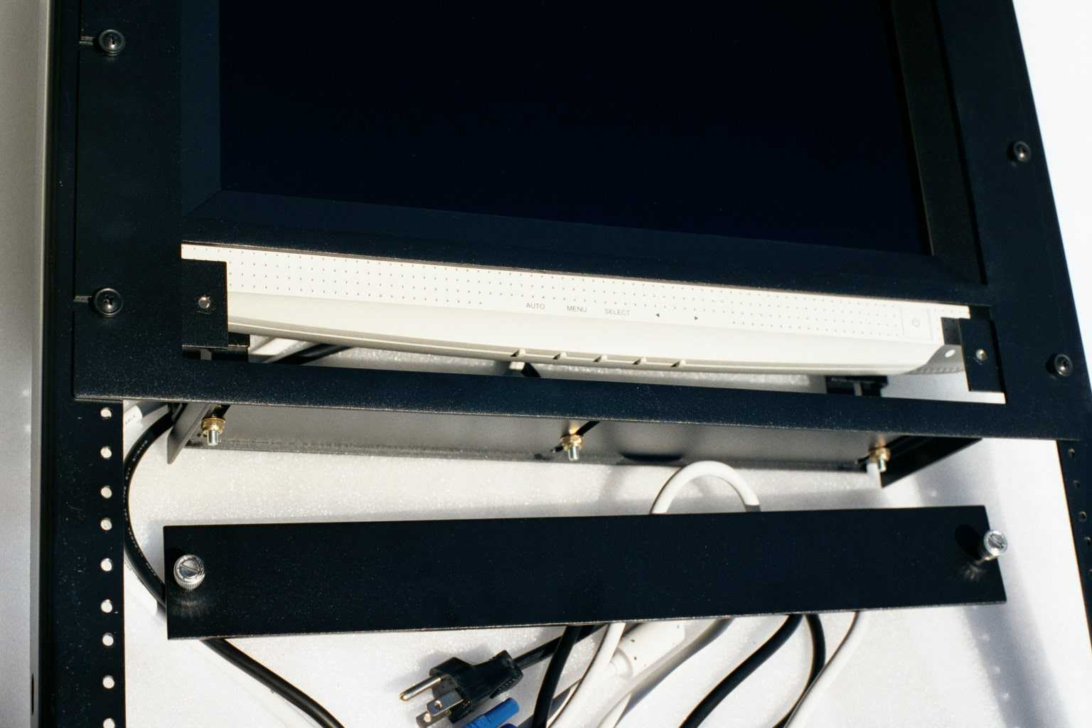 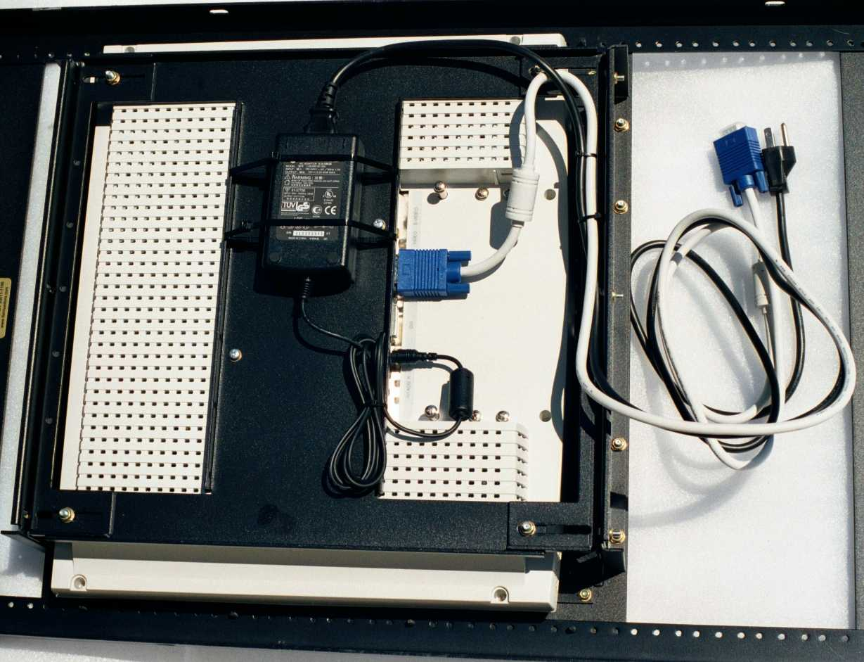 Blank plate opened for access to control buttons Rear view

This rackmount design is for 18.1" TFT LCD flat monitors. Size: 19” X 17.50” X 5.0”. The monitor used here is a Cornea Technology CT1810, which has a contract ratio of 300:1, resolution: 1280 X 1024. Other models such as the Cornea MP800, NEC LCD1830, and Samsung 800TFT will also work.

The workmanship is superb: Picture-frame look, black powder-coated and textured finish, and military grade fasteners.

