
PeiZen, Inc.
651 Via Alondra, Suite 702
CAMARILLO, CA 93012
Phone: (805) 484-2454, FAX: (805) 383-5909
E-mail: hlee@flatmonitors.com
Websites: www.flatmonitors.com and www.peizen.com

Assembly Instructions for mounting the Viewsonic VA712b TFT LCD Monitor onto the Q-1780-RK Rackmount Kit

Tool required:

- No. 2 Phillips screwdriver
- 3/8” socket wrench
- Wire cutter, angle tipped is recommended.

- Remove the monitor from the stand: There are four Phillips round-head metric screws holding the stand. Remove the screws with No. 2 Phillips screwdriver and store them with the stand in the monitor box. In case of warranty service, you will have to reassemble the stand back on the monitor.

- Spread the ¼” thick packing foam that came in the package over a cleared surface or table. Then lay the monitor over the packing foam.

- Place the 1/2” plywood spacers on the right and left sides of the monitor. Then place the corresponding right and left side panels on top of the plywood spacers.

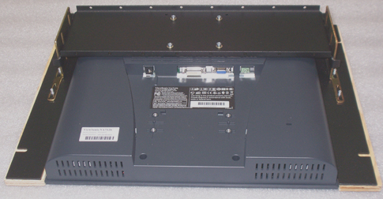
- Mount the rear Omega-bracket onto the monitor. Note: The depth has been pre-adjusted for the monitor to protrude the front panel by about 1/2”, but the depth can be easily readjusted to your preference by using a 3/8” socket wrench.

- Insert a No. 8 flat washer, a No. 8 spring lock washer, and a 4 mm X 12 mm metric screw into each of the four VESA mounting holes on the monitor, then tighten the metric screws with a No. 2 Phillips screw driver.

- Attach the left and right side plates onto the Omega bracket. Adjust the positions of the side plates to make them look even about the monitor. Using a 3/8” socket wrench and secure them with No. 10 flat washers and 10-32 locknuts.
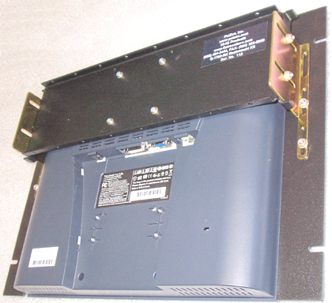

- Put on two weather-strip rubber foam pads on the bottom side of the power adapter, as shown below:

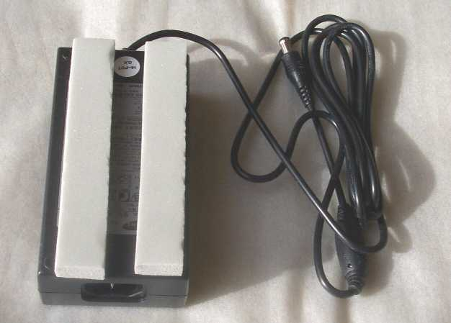

- Position the power adapter as shown below. Feed two 14” tie wraps through the holes on the flanges. Then tighten the tie wraps.

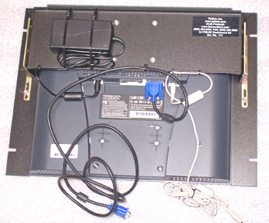

- Connect the power and the VGA cables to the monitor. Then secure them with the 5” tie wraps onto the holes in the Omega bracket. Use wire cutter to cut off the excess ends of the tie wraps.

- The assembly is now ready to be mounted unto a 19" rack. Use the 10-32 X 3/4-inch black screws provided.

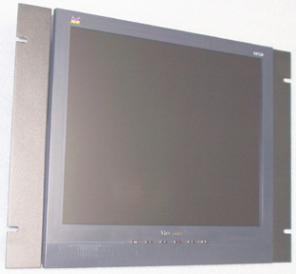

- If you have any questions or comments, please call Harry Lee, 805-484-2454 or e-mail to hlee@flatmonitors.com.

