
PeiZen, Inc.
1227 Flynn Road, Suite 302
Camarillo, CA 93012-6212
Phone: (805) 484-2454, FAX: (805) 383-5909
e-mail: hlee@flatmonitors.com
Website: www.flatmonitors.com

Q-1771-RK

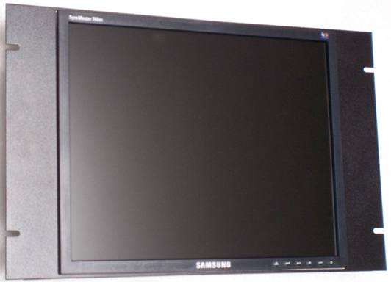

Front view of the Samsung 740Bx-Black assembled onto the Q-1771-RK

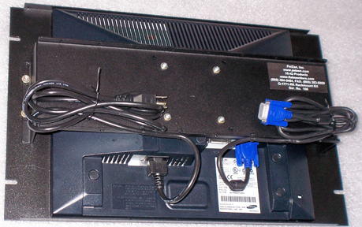 | This rackmount kit is 7U or 12.25” vertical high. The Q-1771-RK is very easy to assemble. It is designed specifically for the Samsung 740Bx-Black, click on http://www.samsung.com/Products/Monitor/LCD_Digital/LS17HAXBBQXAA.asp for its specifications.  The total price for this rackmount monitor assembly can be less than $479.00 when assembled by the customer.
Rear view

