
PeiZen, Inc.
1227 Flynn Road, Suite 302
Camarillo, CA 93012-6212
Phone: (805) 484-2454, FAX: (805) 383-5909
E-mail: hlee@flatmonitors.com
Websites: www.flatmonitors.com and www.peizen.com

Assembly Instructions

For

Q-1572-RK Rackmount Kit onto the Polaroid TLA-01511C 15” monitor

Tool required:

- No. 2 Phillips screwdriver
- 3/8” Socket wrench
- 3/8” Crescent wrench
- Tie wrap tool
- Wire cutter, angled tip is recommended

Procedures:

- It is a good idea to power up and test the monitor before assembling it onto the rackmount kit, just in case if there is any problem with it (usually very rare). Otherwise, you may do all the work below and then have to un-do it. If the monitor is working fine, then lay the foam packing material that came in the box over a flat surface on a table or workbench. The lay the monitor facing down over the soft foam.

- Remove the monitor from its base.

- Use a No. 2 Phillips screwdriver to remove the single locking screw in the stand’s stub. Then put this screw back on the monitor for storage, as shown below:

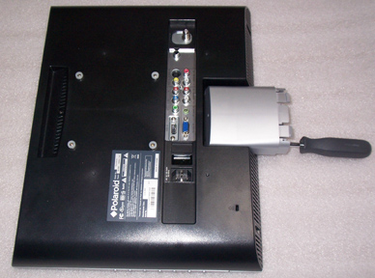 | 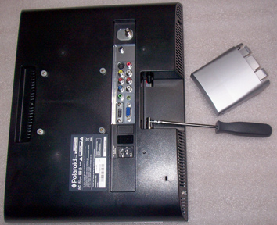

- Remove the wax paper backing on the 1/8” thick spacer bushings and place the sticky side over the VESA mounting holes, as shown below:

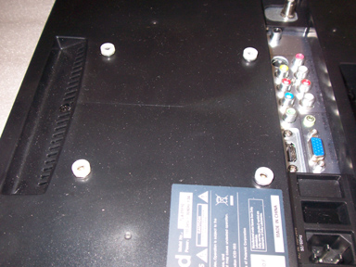

Figure 1. Spacer bushings mounted over the recessed VESA mounting holes.

- Place the front panel onto the rear of the monitor and let it rest on the edges of the monitor, as shown below:

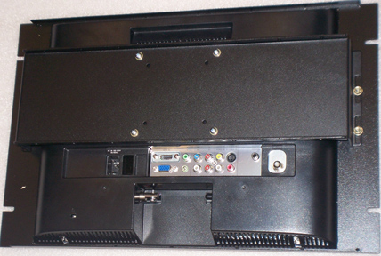

- Mount the U-bracket onto the monitor with four each 4 mm X 16 mm metric screws, No. 8 lock washers, and No. 8 flat washers.

- Mount the front panel onto the U-bracket using No. 10 flat washers and 10-32 locket nuts.

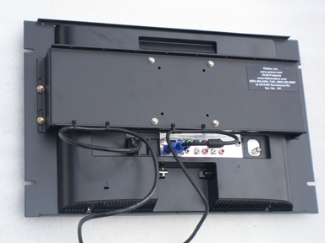
Figure 2. Rear view

- Insert the VGA, the DVI-D, and the power adapter cables onto the monitor.

- Use the 5” tie wraps to secure the cables. Then trim all excess lengths of the tie wraps with a wire cutter.

- The monitor is now assembled. Before mounting it onto a rack, test the rackmount monitor assembly by connecting it to a computer. When done, mount the assembly onto a rack with the four black 10-32 X 3/4” rackmount screws provided.

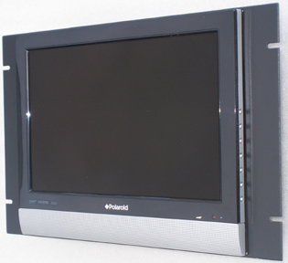

Figure 3. Front View

- Congratulations! You have just completed assembling one of the best-looking and cost-effective 15” rackmount monitor in the world. If you have any questions or comments, please call Harry Lee, 1-866-484-2454 or e-mail to hlee@flatmonitors.com.

