
PeiZen, Inc.
1227 Flynn Road, Suite 302
Camarillo, CA 93012
Phone: (805) 484-2454, FAX: (805) 383-5909
e-mail: hlee@flatmonitors.com
Website: www.flatmonitors.com

Q-1950-RK

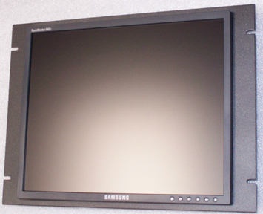

Front view of a similar monitor assembled onto the Q-1950-RK
(The photo is that of the Samsung 940T-Black)

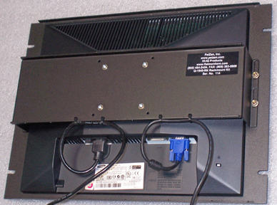 | This rackmount kit is 8U or 14.00” vertical high. The Q-1950-RK is very easy to assemble. It is designed specifically for the Viewsonic VP950b.
Rear view of a similar monitor

