PeiZen, Inc.
1227 Flynn Road, Suite 302
Camarillo, CA 93012-6212
Phone: (805) 484-2454, Toll-free: 866-484-2454
FAX: (805) 383-5909
e-mail: hlee@flatmonitors.com
Website: www.flatmonitors.com

Q-1922-RK
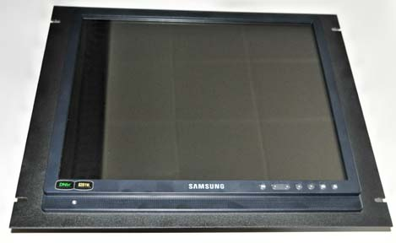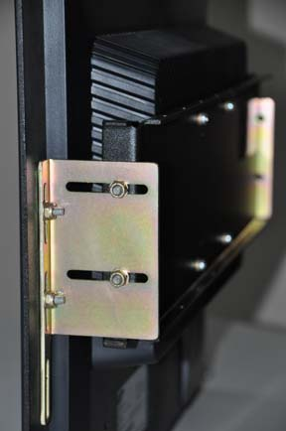
Front view Side view

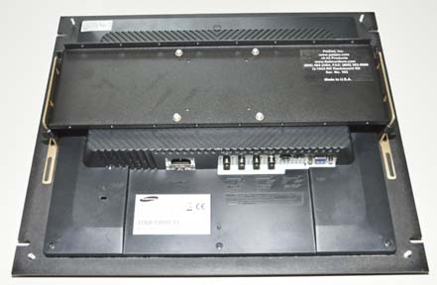 | 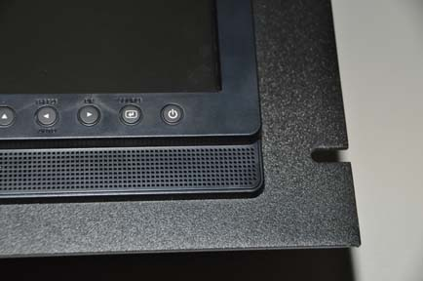
Rear view | Corner view

This rackmount kit is 9U or 15.75” high, specifically designed for Samsung SMT 1922P 19” LCD monitor. Price is $249.00 each, free shipping by Fedex Ground.

