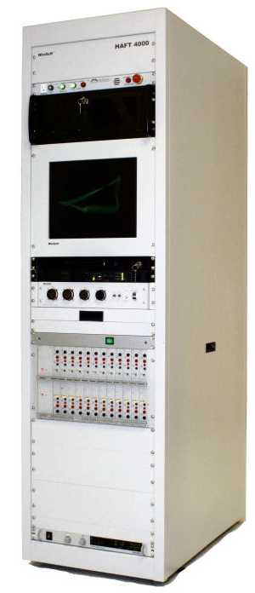 | 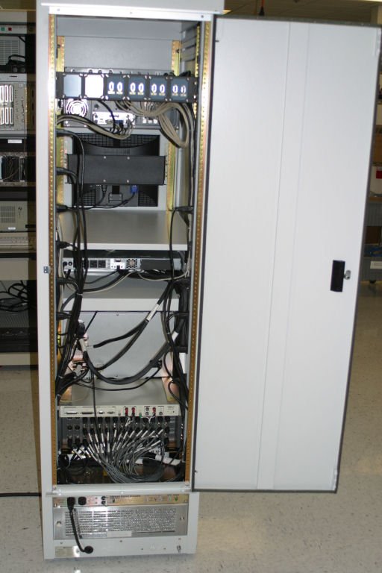

This is a system designed by the Windsoft Corp., and it uses the Q-1710-RK 17” rackmount monitor kit, which has the Winsoft’s logo silkscreen on it.

