Friday, May 31, 2002 11:03 AM

Harry,
I'm sending you two email messages with some attached
pictures of the finished installed monitor assemblies
that we purchased from you. They look beautiful.
Everyone was pleased with them. Hopefully, you'll get
some repeat business from this. These monitors are
installed in our plant simulator and we are hoping
that when the plant operators see the monitors during
their training sessions they will request that they
get the same thing in the plant. Thanks again for all
of your support. I know Ben Martin was very pleased
with the results.
Sincerely,
Bob Werner

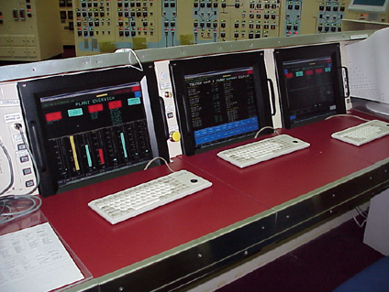

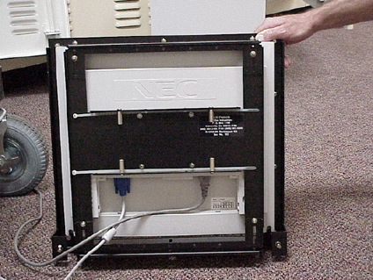 | 